mkdir <projects>

cd <projects>

git clone <https://github.com/bblabla/blabla.git>

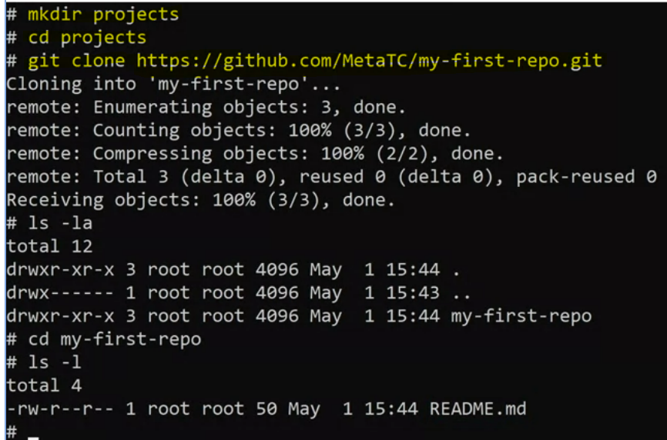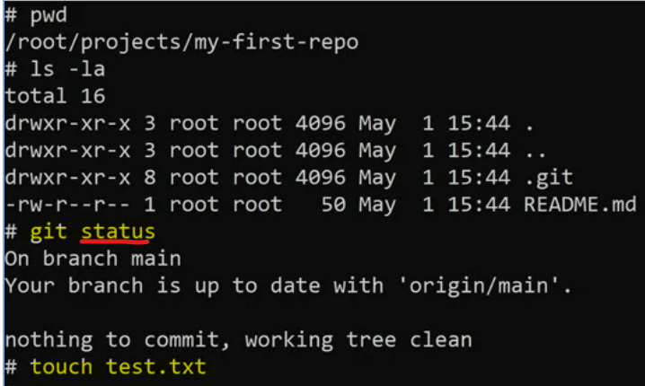

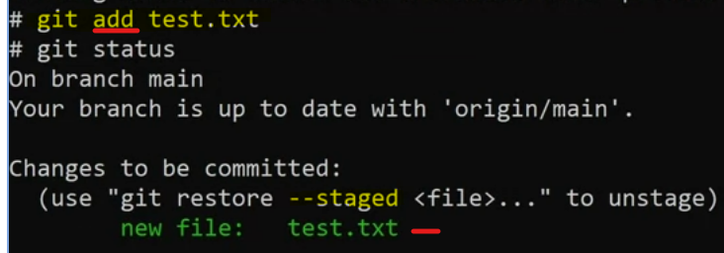

Use git add test.txt to add file back to stage… finished, then…

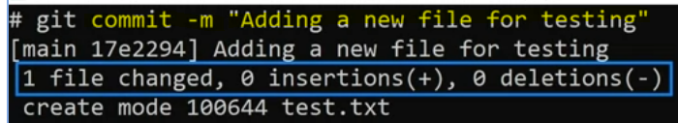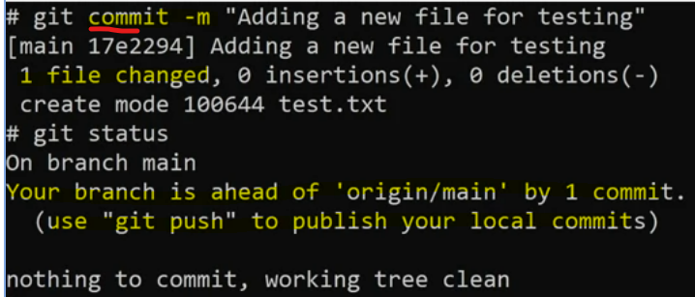

Branches

Create new branche:

* git checkout -B <myNewBranch> => create a branch AND moves you to that branch

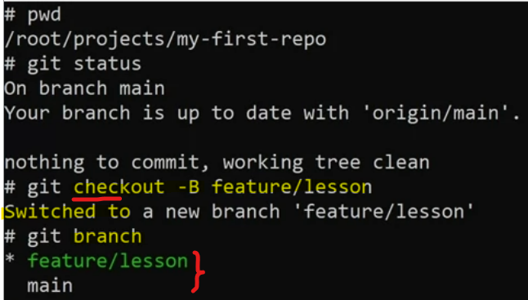 You’re now at feature/lesson branch. Any changes you make will only occur on that new branch

create new file test2.txt, add to stage, commit to local repo, push to branch

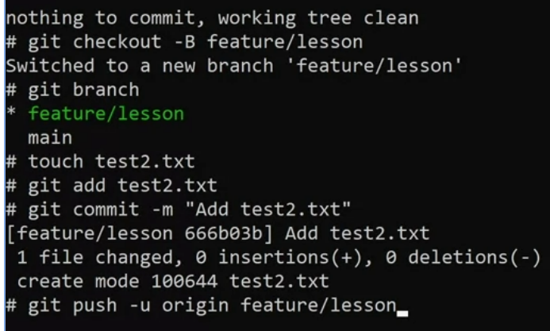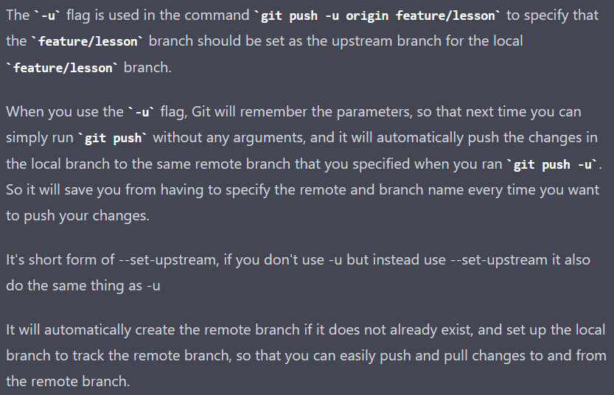

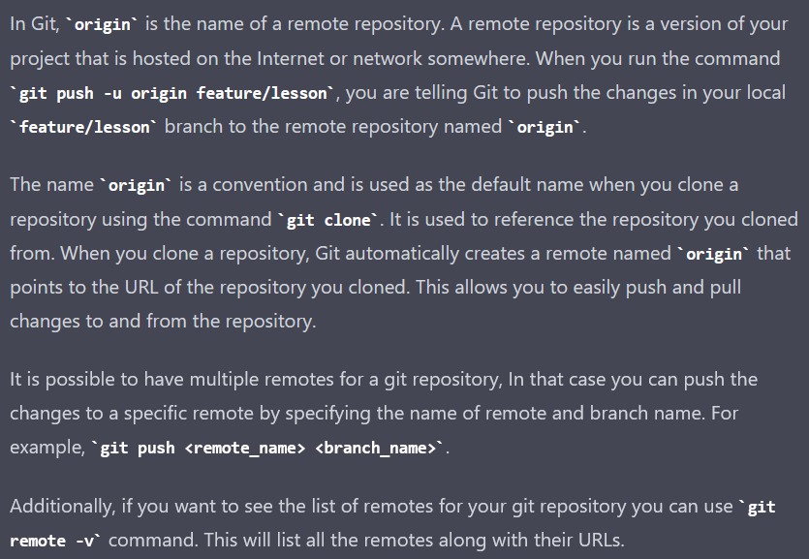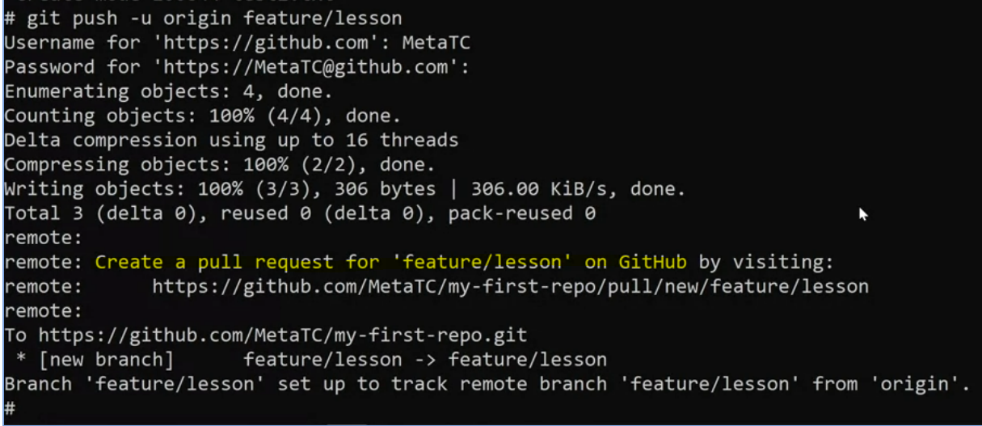

prompt you to create a pull request that can be compared against another branch – the main branch

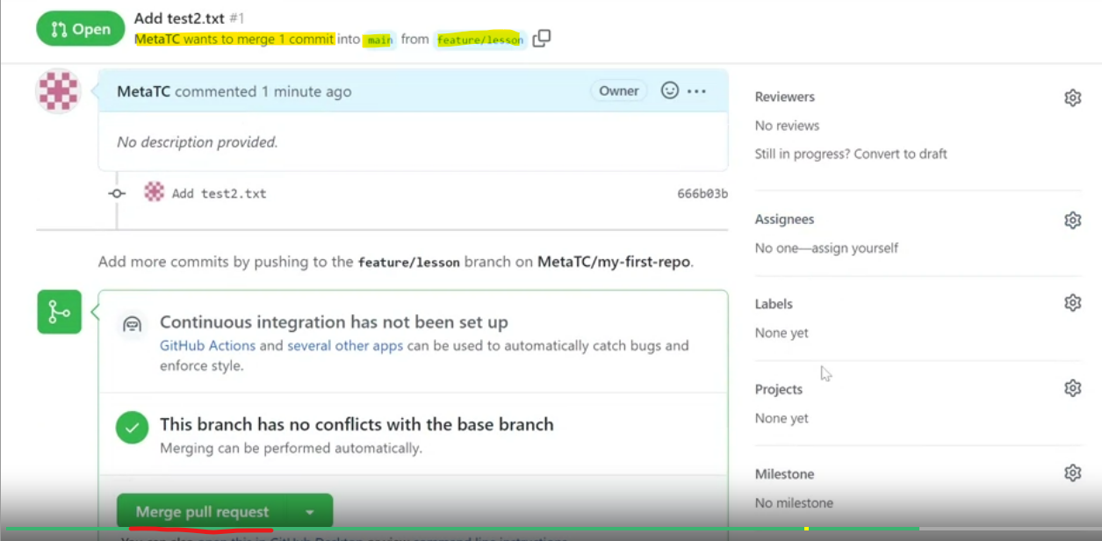

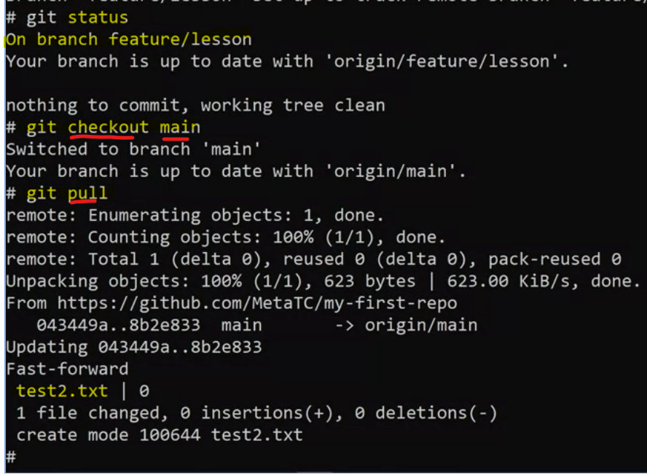

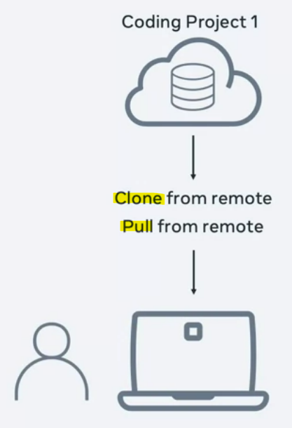 **Clone** is for 1st time, **Pull** for latest changes

Use init to create a local repo, when type git remote, nothing happens, but local repo is not connected to any remote repo yet.

However, cd .., step out to my-first-repo, it is connected to a remote repo.

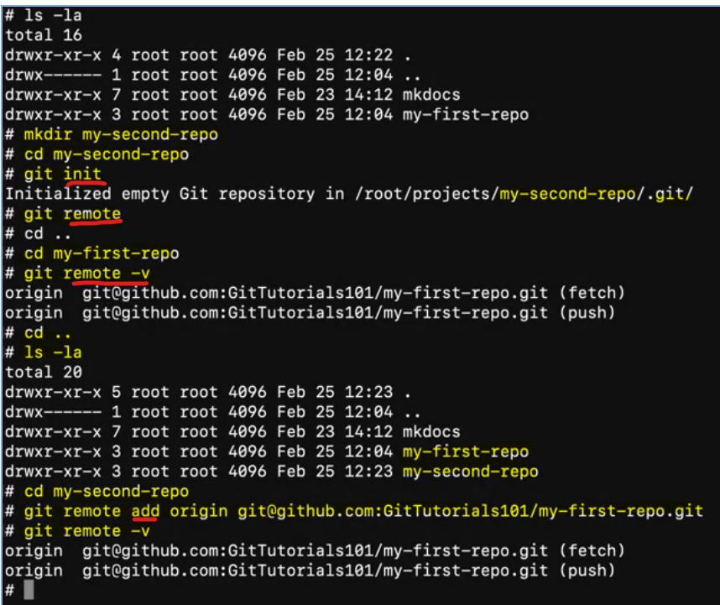

If pull + ls nothing happens, must first checkout main.

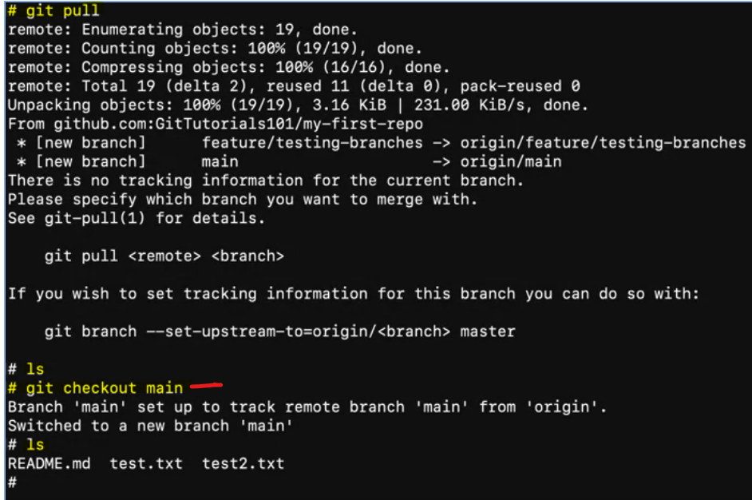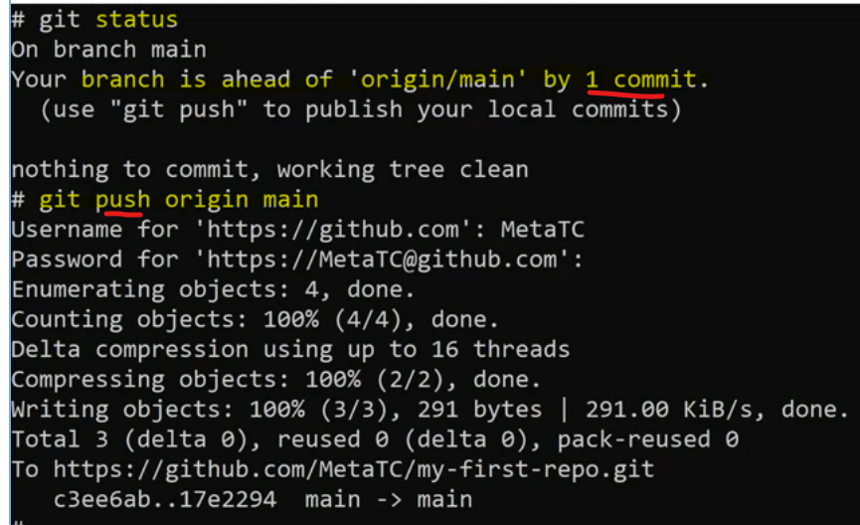

Workflow:

